Petrol Pump Automation

C:\Users\Hp\AppData\Local\Temp\ksohtml16812\wps1.png**Final Year Project - I**

**FYP Team**

**Mahir Saeed 18F-0179**

**Muhammad Affan Khalid 18F-0154**

**Muhammad Taimoor Ali Khan 18F-0482**

**Supervised by**

Rizwan Ul Haq

**Date**

**24 Jan 2022**

**Fall 2021**



**Department of Computer Science**

FAST – National University of Computer & Emerging Sciences

Chiniot-Faisalabad Campus

**Acknowledgement**

This documentation consumed a lot of work, research, and dedication. It was not possible without help of our teachers and supervisors. We would like to extend our sincere gratitude to them.

We are thankful to FAST National University of Computer and Emerging Sciences for their support and for providing necessary guidance concerning project.

We are also grateful to both our supervisors Rizwan Ul Haq for provision of expertise, and technical support. Without their superior knowledge and experience, the documentation would never have brought the quality outcomes, and thus their support has been essential.

We shall soon start the implementation of the project after the acceptance of documents.

**Intellectual Property Right Declaration**

**This is to declare that the work under the:**

**Title: ADS carried out in partial fulfillment of the requirements of:**

**BS FYP MS Research Survey MS Thesis Course Project**

is the sole property of the National University of Computer and Emerging Science, and is protected under the intellectual property right laws. It can only be considered/used for purposes like extension for further enhancement, product development, adoption for commercial/organizational usage, etc., with the permission of the University

This above statement applies to all students and faculty.

Date: ______________

Student 1

Name: Mahir Saeed

Signature: __________________

Student 2

Name: Muhammad Affan Khalid

Signature: __________________

Student 3

Name: Muhammad Taimoor Ali Khan

Signature: __________________

Supervisor (Faculty)

Name: Rizwan Ul Haq

Signature: __________________

**Anti-Plagiarism Declaration**

This is to declare that the above publication produced under the:

**Title: Petrol Pump Automization**

is the sole contribution of the author(s) and no part hereof has been reproduced on as it is basis (cut and paste) which can be considered as **Plagiarism.** All referenced parts have been used to argue the idea and have been cited properly. We will be responsible and liable for any consequence if violation of this declaration is determined.

Date: ______________

Student 1

Name: Mahir Saeed

Signature: ________________

Student 2

Name: Muhammad Affan Khalid

Signature: ________________

Student 3

Name: Muhammad Taimoor Ali Khan

Signature: ______________

Table of Contents

1.1: Introduction 2

**1.1.1: Purpose** 2

**1.1.2: Objectives** 2

**1.1.3: Scope** 3

**1.1.4: Abbreviation, definition** 3

**1.1.5: Intended Audience and Reading Suggestions** 3

1.2: Positioning: 4

**1.2.1-Business Opportunity:** 4

**1.2.2: Problem Statement** 4

1.3: Stakeholder and User Descriptions 5

**1.3.1: Market Demographics:** 5

**1.3.2: Stakeholder Summary:** 6

**1.3.3: User Summary** 6

**1.3.4: User Environment** 7

**1.3.5: Stakeholder or User Needs** 7

1.4: Product Overview 7

**1.4.1: Product Perspective** 8

**1.4.2: Summary of Capabilities** 8

1.6: Functional Requirements 9

1.7: Other Non-Functional Requirements 9

**1.7.1 Availability:** 9

**1.7.2. Compatibility:** 9

**1.7.5 Supportability:** 9

**1.7.6. Security:** 9

3. Use Case 10

**3.1: System Use Case Diagram** 10

**3.2: High level Use Case** 11

4: Iteration 1 14

**4.1: Expanded Use Cases** 15

**4.2: Activity Diagram** 16

**4.3: Domain Model** 17

**4.4: System Sequence Diagram** 18

**4.4.1 Dispense Fuel** 18

**4.5: Sequence Diagram** 19

**4.6: Class Diagram** 20

**4.7: Architecture Diagram** 21

5: Iteration 2 22

**5.1: Expanded Use case** 22

**5.2: Activity Diagram** 23

**5.3: Domain Model** 24

**5.4: System Sequence Diagram** 25

**5.4.1: Dispense Fuel** 25

**5.5: Sequence Diagram** 26

**5.6: Class Diagram** 27

**5.7: Architecture Diagram** 28

# 

# **Table of Figures**

Figure 1 Use Case Diagram 10

Figure 2 Iteration Plan 14

Figure 3 Activity Diagram 16

Figure 4 Domain Model 17

Figure 5 System Sequence Diagram of Dispense Fuel 18

Figure 6 Sequence Diagram 19

Figure 7 Class Diagram 20

Figure 8 Architecture Diagram 21

Figure 9 Activity Diagram 23

Figure 10 Domain Model 24

Figure 11 Dispense Fuel 25

Figure 12 Sequence Diagram 26

Figure 13 Class Diagram 27

Figure 14 Architecture Diagram 28

**1: Document Version**

*Table 1- Version of Vision Document*

|  |  |  |  |
| --- | --- | --- | --- |
| **Version** | **Date** | **Description** | **Authors** |
| V1.2 | 24/1/2022 | Petrol Pump Automization | Mahir Saeed Muhammad Affan Khalid Muhammad Taimoor Ali Khan |

# 

# 

# **1.1: Introduction**

This document collects, analyzes, and defines the high-level needs and features of the Petrol Pump Automization.We are using an efficient automated system to remove all paper work and to minimize the human errors. Sensors are used for measuring the tanker and calculating the daily sales of petrol and maintaining the data of sales and employee in servers. Fingerprint sensors are used for employee attendance, marking their working hours and also used to maintain the safety of main tank by sending a message to the admin when open or closed. Fire alarms notification are used to notify admin in order to take emergency measures.

## **1.1.1: Purpose**

Automation of pumps will give owner accurate data on sales and control over any adulteration. The current system is not efficient, which results in the impure petrol. Many customer complaints are bad quality petrol which results in reduced engine performance and engine quality and higher emission. The impure petrol can be avoided if an optimal automated system is used.

## **1.1.2: Objectives**

* Automation of readings of main tanker and fuel dispenser
* Automation of daily sales calculation of fuel and money.
* Human error is reduced
* Daily Sales can be viewed any time online.
* Notifying admin on Fire hazards
* Employee working hours are maintained
* Employee salary record is maintained
* Main tank is secured from frauds by employees.

## **1.1.3: Scope**

Now a day every petrol pumps work is done manually causing the fuel reading miscalculation, having low accuracy, fuel impurities and fuel frauds causing loss to pump owner. Now our Automated system provide all work automated and have high accuracy, giving fuel safety and securities and saving from any fuel frauds. This automated system provides high accuracy, fuel safety and security saving from any impurities and any type of frauds.

## **1.1.4: Abbreviation, definition**

Following are the abbreviation and definitions used in the document:

* FAST-NU: Foundation of Advancement of Science and Technology-National University
* CFD: Chiniot Faisalabad
* NUCES: National University of Computer and Emerging Sciences

## **1.1.5: Intended Audience and Reading Suggestions**

The intended audience for the following document is developers and the users of the application. The main audience are:

* **Development Team** will use this document to design and develop a desktop-based application according to the customer requirements.
* **Users** will use this document to learn about the features of the system and get information about how to use the system.
* **Testers** will use this document before writing test cases because this will act as a contract between customer and contractor. Tester will validate user requirements.

The rest of the document contains the functional requirements, non-functional requirements, deployment information and dependencies.

# **1.2: Positioning:**

Positioning tells us that how our application grows, and we can earn money through this application in the market, it defines business opportunity and defines the Problem statement that why we need to develop this application.

Details are given below:

## **1.2.1-Business Opportunity:**

Problems that require continuous, constrained, and deterministic optimization can be resolved to an optimal solution using the automization techniques that we will implement and map to our problem. Frayed tempers and altercations over short measurement at petrol pumps may soon become a thing of the past, with public sector oil marketing companies taking steps to automate their pumps. People require travelling whether for daily jobs, events or any other events. Our Automization will help them by giving a good quality fuel for their daily ride saving their vehicle health.

## **1.2.2: Problem Statement**

|  |  |
| --- | --- |
| The problem of | Issues regarding bad quality and impure petrol |
| that affects | Person having vehicle. |
| The impact of which is | When petrol gets ignited before the intended spark ignition, it results in uncontrolled explosions in the engine. Since these detonations are uncontrolled, it hurts the engine and they fail to last a long time. |
| A successful solution would be | An Automated based pump to save it from getting hands on petrol of employee to save from getting impure. |

*Table 1: Problem statement*

# 

# **1.3: Stakeholder and User Descriptions**

The automated system to be developed helps help to guarantee the fuel safety and monitors the sales and employee.

* Admin can easily manage information regarding employee
* Admin can view the daily sales report of fuel dispensed from tanker and dispensers.
* Admin can also generate sales reports and fuel reports from specific date to current dates
* Admin can get information regarding working employee
* Employee can mark their attendance using fingerprint, when their working hours starts.
* Receipt is generated for customer after every vehicle gets filled

The stakeholders for this application are FAST-NUCES, developers and the users of this application.

## **1.3.1: Market Demographics:**

Petrol pumps having no oil security results in oil frauds and impurity. Automated Petrol Pump can be tuned to carter the needs of such security issues. The most common issue faced by the pump owners are petrol fraud and bad quality fuel. Thus, Automated Petrol Pump can be proved as a viable system for such issues. However, the target market for Petrol Pump Automization is pump owners.

**1.3.2: Stakeholder Summary:** Table 5-Stakeholder Summary

|  |  |  |
| --- | --- | --- |
| **Name** | **Description** | **Responsibilities** |
| FAST-CFD Faculty | Have copyrights of our Final Year Project | Provide resources and facilitate to develop this application. |
| Rizwan Ul Haq | Supervisor of the project. | Facilitate the development team to develop the project. |
| Mahir Saeed | Member of the development team. | Development of project. |
| Muhammad Affan Khalid | Member of the development team. | Development of project |
| Muhammad Taimoor Ali Khan | Member of development team. | Development of project |

## **1.3.3: User Summary**

Table 3-User Summary

|  |  |  |  |
| --- | --- | --- | --- |
| **Name** | **Description** | **Responsibilities** | **Stakeholder** |
| Admin | Primary end user of the system | 1. manage employee data  2. Generate reports  3. Print and View the reports. | Self |
| User/operator | Primary end user of the system | Dispensed the fuel | Self |

## **1.3.4: User Environment**

* 1 person will lead the development and 2 people are member of this project.
* Total duration of this project is 1 year. We will complete our documentation within 2 months and work on implementation for 10 months.
* We will be using react, java and the necessary frameworks to make the web and android application.

## 

## **1.3.5: Stakeholder or User Needs**

Table 4-Stakeholder or User Needs

|  |  |  |  |  |
| --- | --- | --- | --- | --- |
| **Need** | **Priority** | **Concerns** | **Current Solution** | **Solution** |
| Easy to Use | High | User can easily use the application without any difficulty. | None | Provide user friendly interface and instructions on how to use th application. |
| Performance | High | Incorrectness in readings can cause a huge problem, and they result in wasted time and resources. | None | Use automated based system for high accuracy. |

# **1.4: Product Overview**

This field is used to give overall view related to product. The information gives in this section must be accurate precise, specific and relate to the project, which describes the perspective and features of product.

## **1.4.1: Product Perspective**

This product will be web and android based and will provide a user-friendly interface so the user can perform the functions easily and need an internet connection. To use the application, the user will have to log in using the log in information. After login user can generate sales reports and can view the fuel levels and can take readings.

## **1.4.2: Summary of Capabilities**

Table 8-: Summary of Capabilities

|  |  |
| --- | --- |
| **Customer Benefit** | **Supporting Features** |
| A safe pure fuel for engines. | Automated based petrol pump that will monitor the petrol. |
| The receipt will be generated of total dispensed fuel. | The system will show the fuel price rate and total bill and dispensed fuel in liters. |

# 

# 

# **1.6: Functional Requirements**

1. Admin shall be able to manage the employee information.
2. Admin shall be able to generate sales and readings reports.
3. Admin shall be able to view the details of the clashes.
4. Employee shall be able to mark their bio-metric attendance at the start and end of their working hours.
5. Dispenser shall be able to generate dispensed fuel receipts for customers.
6. Admin shall be able to view tanker level and dispenser reading at the start and end of the day.
7. Admin shall be able view tanker lock status.
8. System shall be able to notify admin about fire hazard emergency.

# **1.7: Other Non-Functional Requirements**

## **1.7.1 Availability:**

Our system should be available 24/7

## **1.7.2. Compatibility:**

Our system should be enough capable they will be easily working in the background and also on the both android and desktop system/

**1.7.4. Maintainability:**

The system should be maintainable. The system should be able to adapt new features. Previous functionality should not be disturbed in case of adding new functionality.

## **1.7.5 Supportability:**

Our application will be supported on Microsoft Windows and on android mobiles

## **1.7.6. Security:**

Our system should be secure because if user want to login or access the confidential information he must have to enter the desired key or information to access that information

# **3. Use C****ase**

## **3.1: System Use Case Diagram**

Use Case Diagram is given below.

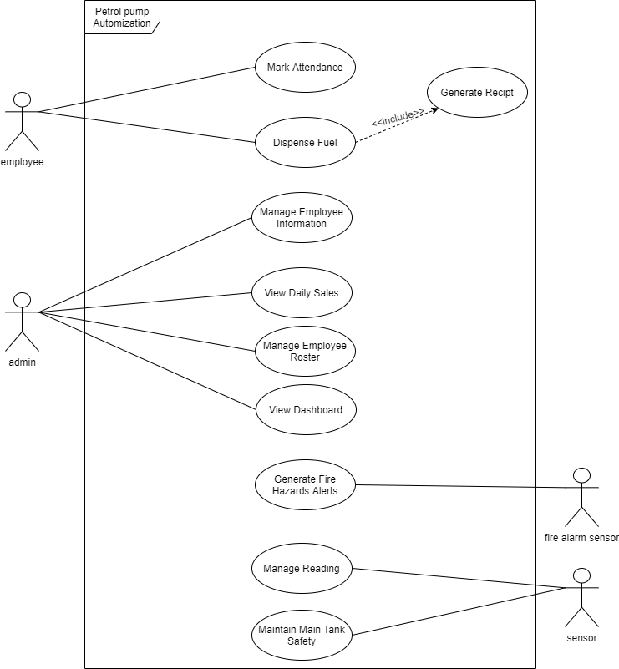

Figure 1 Use Case Diagram

## **3.2: High level Use Case**

#### UC-1: Mark Attendance

*Table 5 Use case 1*

|  |  |
| --- | --- |
| **Mark Attendance** | |
| ID: | UC-1 |
| Use case: | Mark Attendance |
| Actor: | Employee |
| Type: | Primary |
| Description: | Employee will be able to mark their attendance using fingerprint when their working hours start and end |

#### UC-2: Manage Employee Information

*Table 6 Use case 2*

|  |  |
| --- | --- |
| **Manage Employee Information** | |
| ID: | UC-2 |
| Use case: | Manage Employee Information |
| Actor: | Admin |
| Type: | Primary |
| Description: | Admin will be able to manage all the information of employee |

#### UC-3: View Daily Sales

*Table 7 Use case 3*

|  |  |
| --- | --- |
| **View Daily Sales** | |
| ID: | UC-3 |
| **Use case:** | View Daily Sales |
| Actor: | Admin |
| Type: | Primary |
| Description: | Admin will be able to view the daily sales at any time. |

#### UC-4: Manage Employee Roster

*Table 8 Use case 4*

|  |  |
| --- | --- |
| **Manage Employee roster** | |
| ID: | UC-4 |
| Use case: | Manage Employee roster |
| Actor: | Admin |
| Type: | Primary |
| Description: | Admin will be able to see the current working employee. |

#### UC-5: View Dashboard

*Table 9 Use case 5*

|  |  |
| --- | --- |
| **View Dashboard** | |
| ID: | UC-5 |
| Use case: | ViewDashboard |
| Actor: | Admin |
| Type: | Primary |
| Description: | Admin will be able to see the remaining, dispensed fuel, pricing rates. |

#### UC6: Generate Fire Hazard Notification

*Table 10 Use case 5*

|  |  |
| --- | --- |
| **Generate Fire Hazard Notification** | |
| ID: | UC-6 |
| Use case: | Generate Fire Hazard Notification |
| Actor: | Fire alarm sensor |
| Type: | Secondary |
| Description: | System will be able to generate the notification or call if the emergency occurs. |

#### UC-7: Manage Readings

*Table 11 Use case 7*

|  |  |
| --- | --- |
| **Manage readings** | |
| ID: | UC-7 |
| Use case: | Manage readings |
| Actor: | sensor |
| Type: | Secondary |
| Description: | Sensors will be able to get the dispenser and tanker readings. |

#### UC-7: Maintain Tanker Safety

*Table 12 Use case 8*

|  |  |
| --- | --- |
| **Maintain Main Tanker Safety** | |
| ID: | UC-8 |
| Use case: | Maintain Main Tank Safety |
| Actor: | sensor |
| Type: | Secondary |
| Description: | System will be able to monitor tanker lock. |
|  |  |

# 

# **4: Iteration 1**

We will be developing our software according to the iteration plan as shown in the figure

Requirement

Specification Documentation Implementation Testing Deployment

Sep

Oct

-

Dec

Iteration PlanJan

-

May

June

July

Figure 2 Iteration Plan

## **4.1: Expanded Use Cases**

The features of our system are given below. These are the major features which has been described below

#### EUC-1: Dispense Fuel

|  |  |
| --- | --- |
| **Get Summary** | |
| ID: | UC-1 |
| Use case: | Dispense fuel |
| Actor: | Employee |
| Type: | Primary |
| Description: | The dispenser will show the dispensed fuel. |
| Pre-condition: | The dispenser meter should be zero. |
| Post-condition: | The dispenser will generate the receipt according to the fuel dispensed. |
| Normal flow: | 1. Employee enter the price 2. Employee dispenses the fuel 3. Dispenser generates the receipt |
| Alternative flow: | 1. Employee enters in liters. 2. Dispenser shuts down due to electricity, backup generators are used. 3. Dispenser generates the receipts using back generators. |
| Frequency: | High |
|  |  |
|  |  |

## **4.2: Activity Diagram**

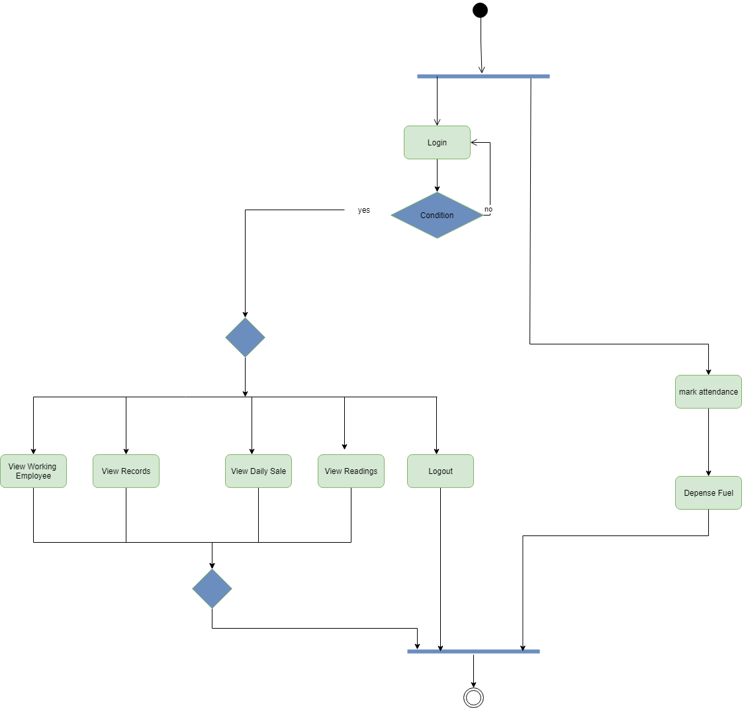

Figure 3 Activity Diagram

# 

## **4.3: Domain Model**

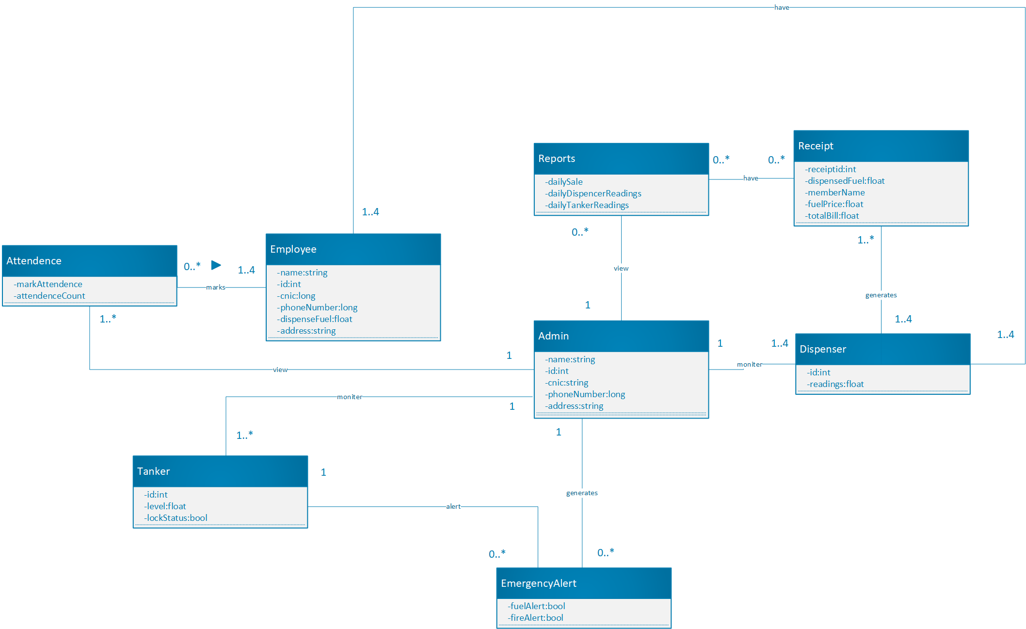

Figure 4 Domain Model

## **4.4: System Sequence Diagram**

System Sequence Diagram are given below:

### **4.4.1 *Dispense Fuel***

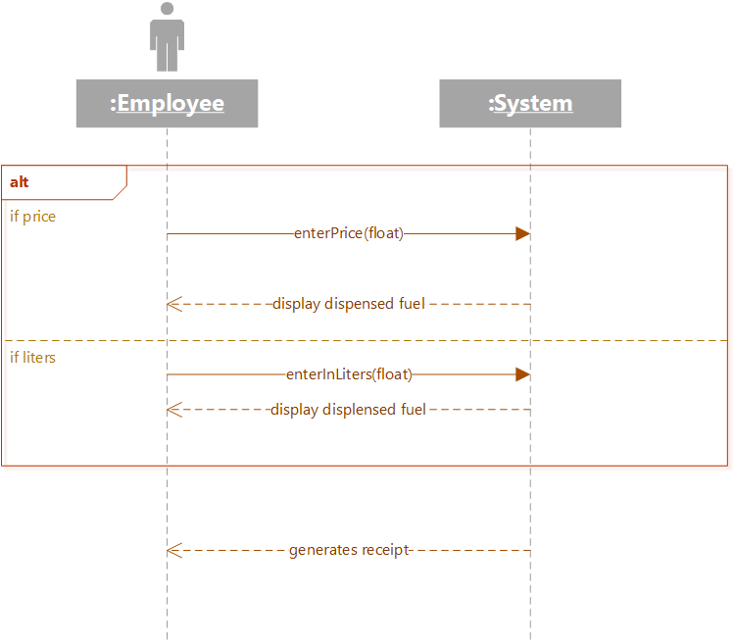

Figure 5 System Sequence Diagram of Dispense Fuel

# 

## **4.5: Sequence Diagram**

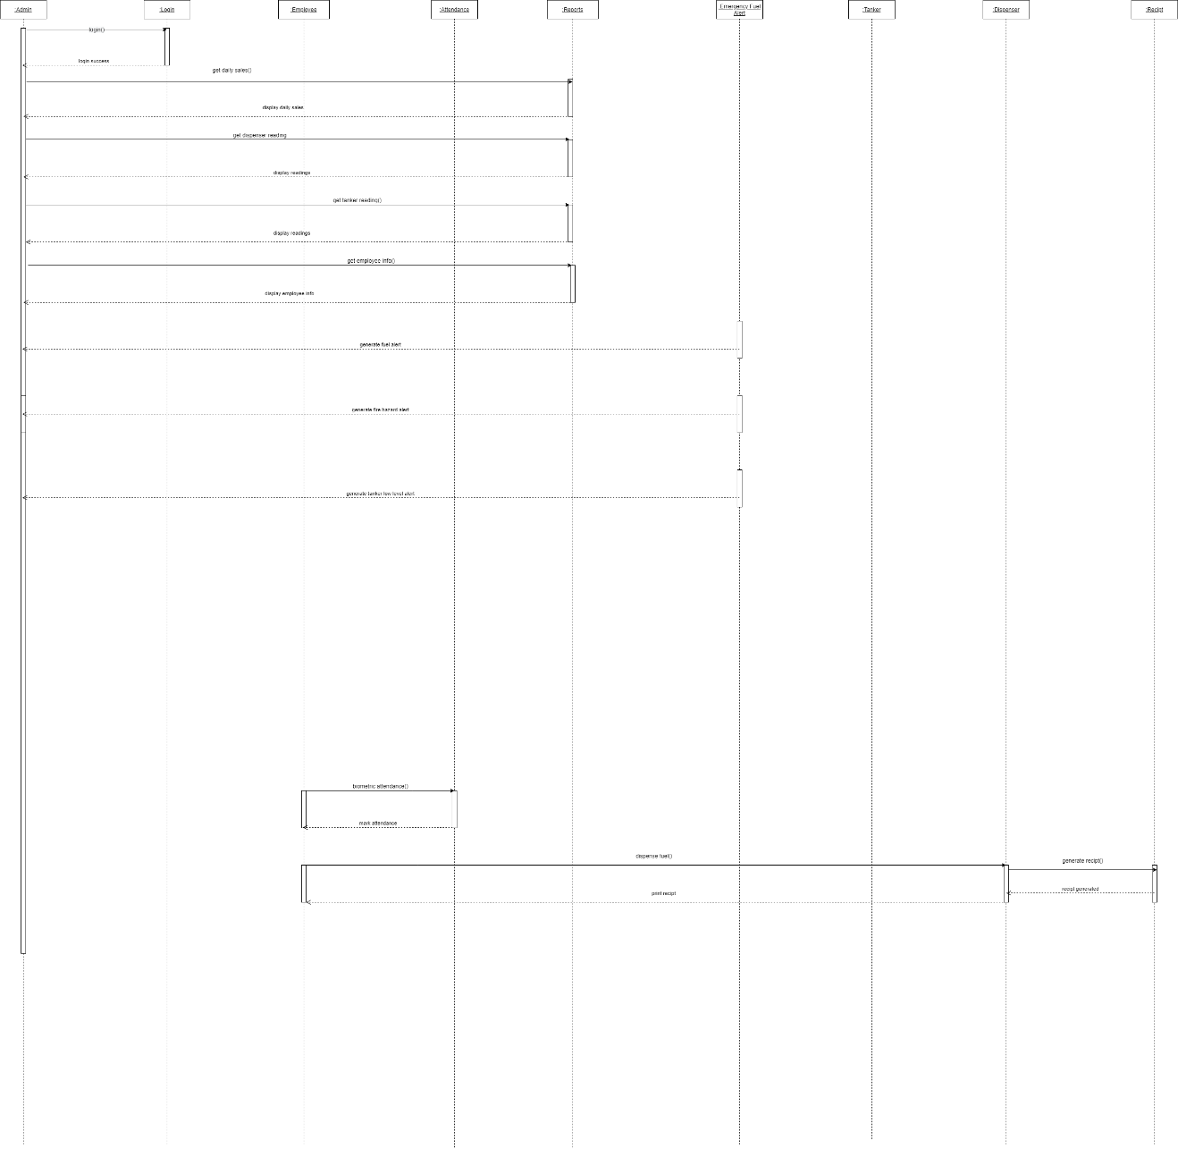

Figure 6 Sequence Diagram

## **4.6: Class Diagram**

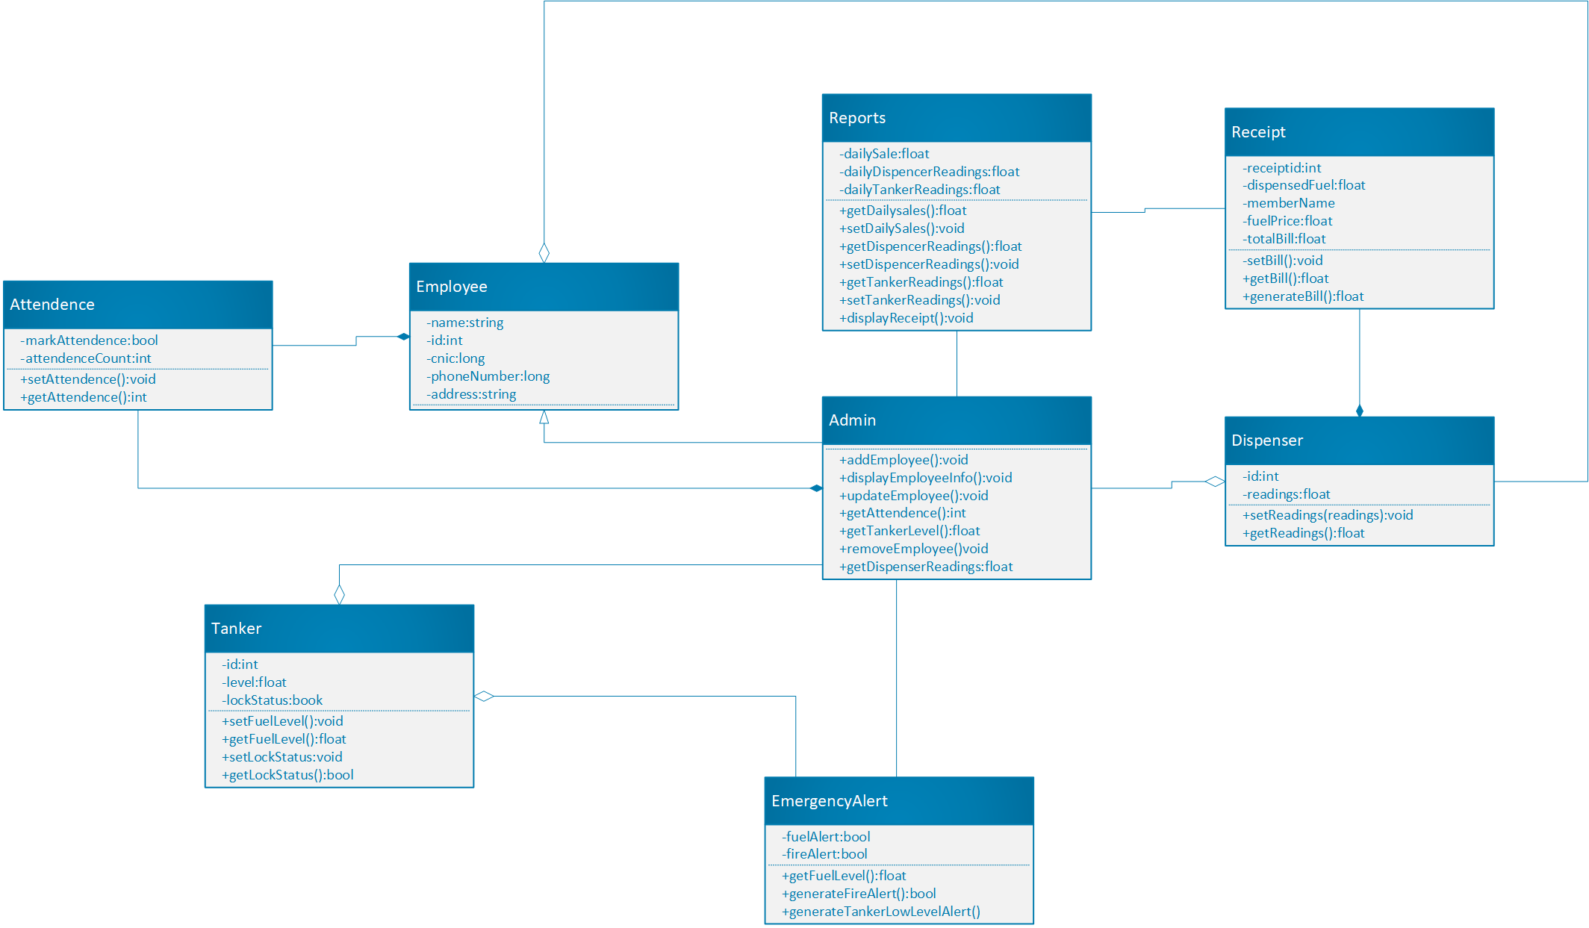

Figure 7 Class Diagram

## **4.7: Architecture Diagram**

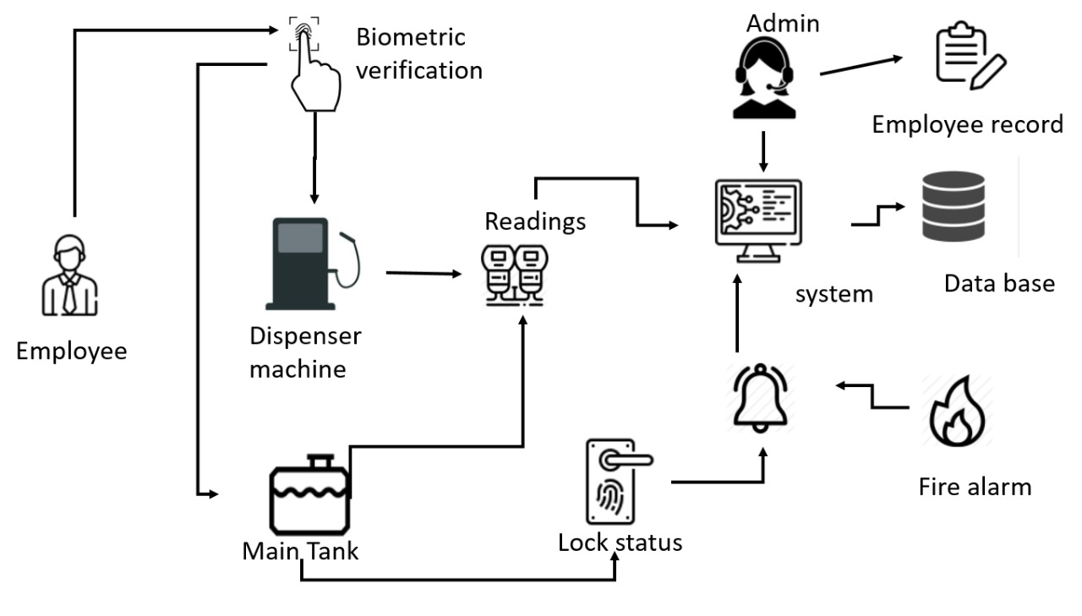

Figure 8 Architecture Diagram

# 

# **5: Iteration 2**

## **5.1: Expanded Use case**

Table 1 Dispense Fuel

|  |  |
| --- | --- |
| **Get Summary** | |
| ID: | UC-1 |
| Use case: | Dispense fuel |
| Actor: | Employee |
| Type: | Primary |
| Description: | The dispenser will show the dispensed fuel. |
| Pre-condition: | The dispenser meter should be zero. |
| Post-condition: | The dispenser will generate the receipt according to the fuel dispensed. |
| Normal flow: | 1. Employee enter the price 2. Employee dispenses the fuel 3. Dispenser generates the receipt |
| Alternative flow: | 1. Employee enters in liters. 2. Dispenser shuts down due to electricity, backup generators are used. 3. Dispenser generates the receipts using back generators. |
| Frequency: | High |
|  |  |
|  |  |

## **5.2: Activity Diagram**

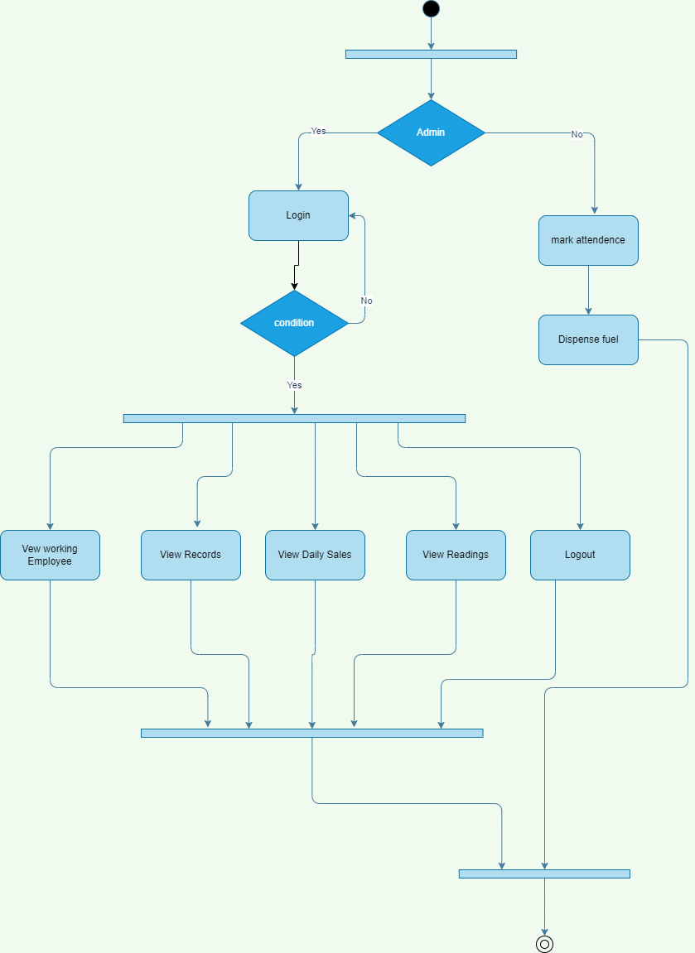

Figure 9 Activity Diagram

## **5.3: Domain Model**

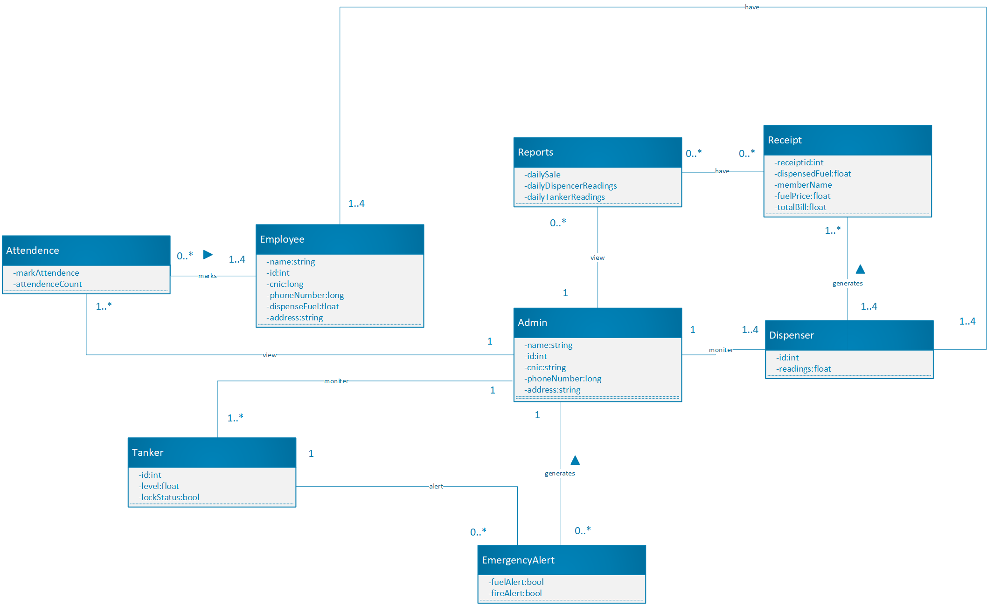

Figure 10 Domain Model

## **5.4: System Sequence Diagram**

### ***5.4.1: Dispense Fuel***



Figure 11 Dispense Fuel

## **5.5: Sequence Diagram**

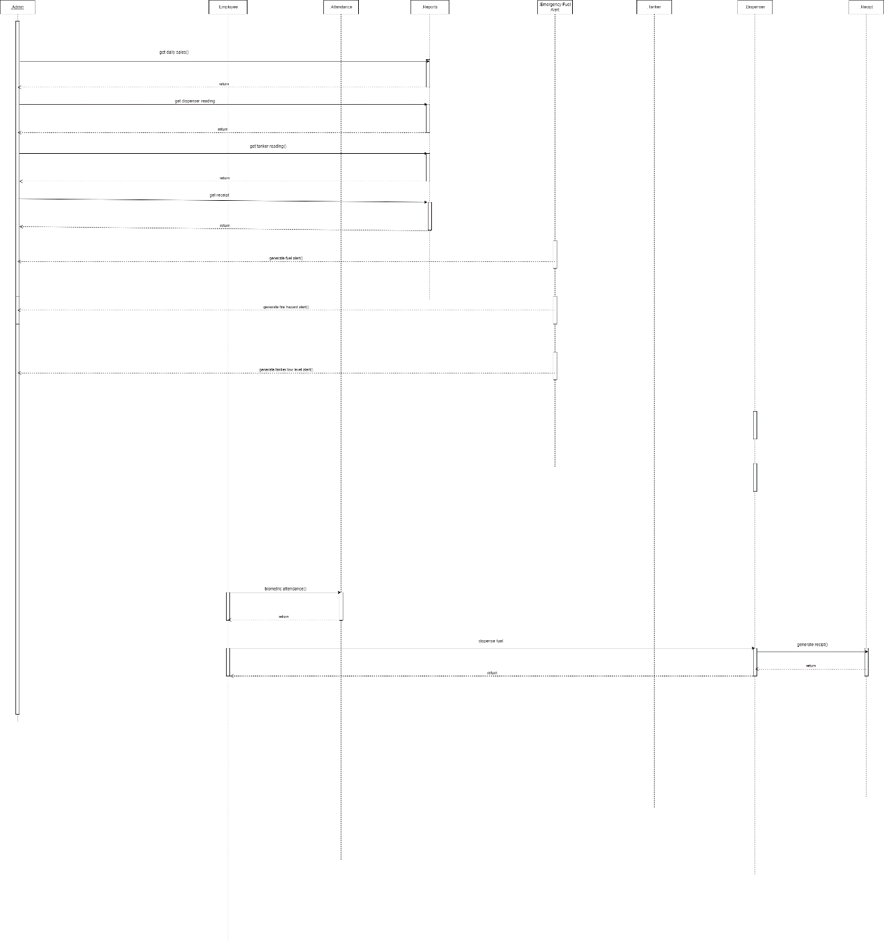

Figure 12 Sequence Diagram

## **5.6: Class Diagram**

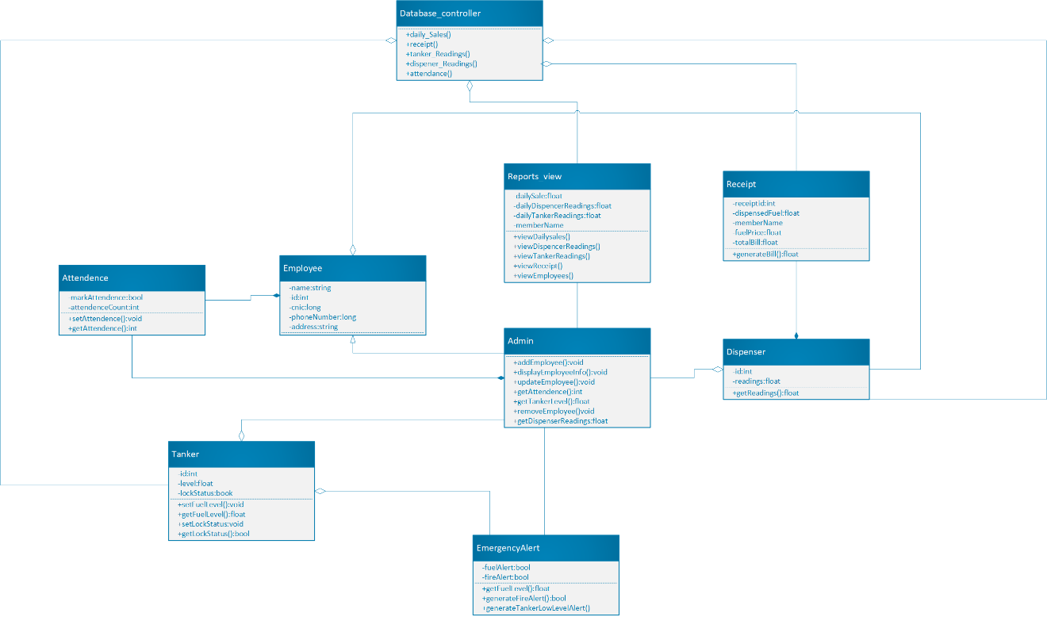

Figure 13 Class Diagram

## **5.7: Architecture Diagram**



Figure 14 Architecture Diagram